Project Design Phase-I Solution Architecture

|  |  |
| --- | --- |
| Date | 19 September 2022 |
| Team ID | PNT2022TMID51330 |
| Project Name | Digital Naturalist - AI Enabled tool for  Biodiversity Researchers |
| Maximum Marks | 4 Marks |

Solution Architecture Diagram:

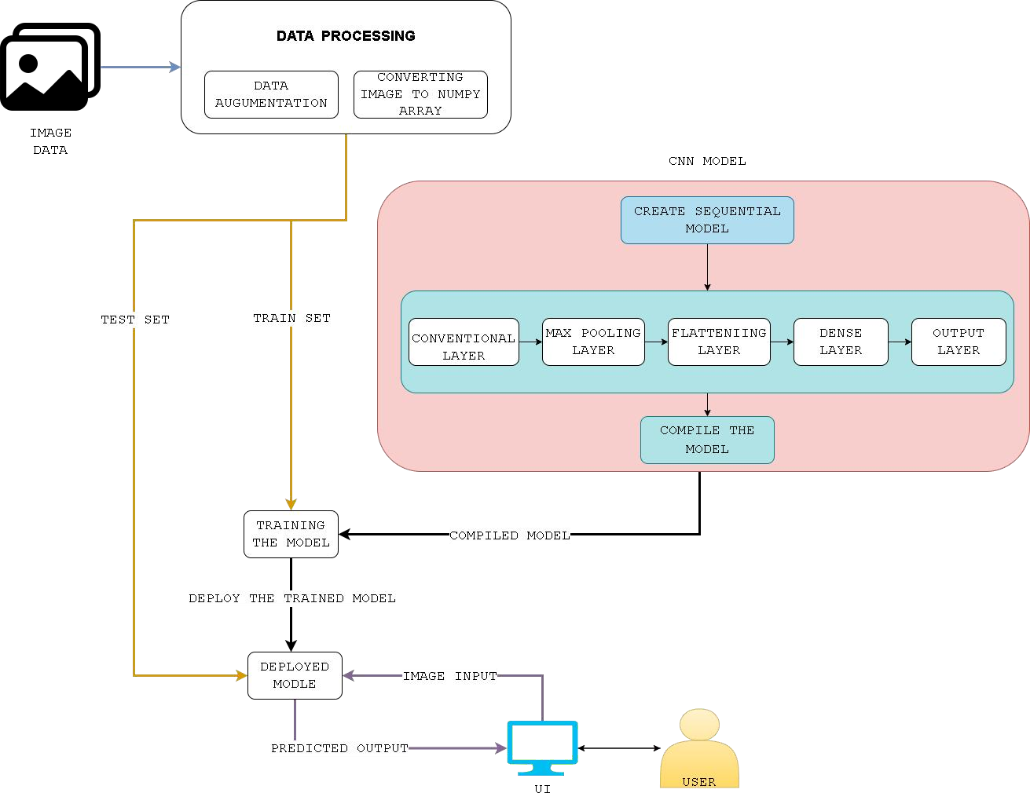

*Figure 1: Architecture and data flow of the Digital Naturalist* - AI Enabled tool for Biodiversity Researchers